**NGUYEN HOANG VINH**

**2132300522**

**MIS 443**

**QUARTER 4 / 2024 - 2025**

**FINAL EXAM**

**Question 1: Create a database named “yourfullname” (e.g: dangthaidoan”) use PGAdmin, then create a schema name “cd” that has three tables: members, bookings and facilities using SQL statements. Ensure each table includes appropriate primary and foreign keys, and data types.**

1. **Check tables:**

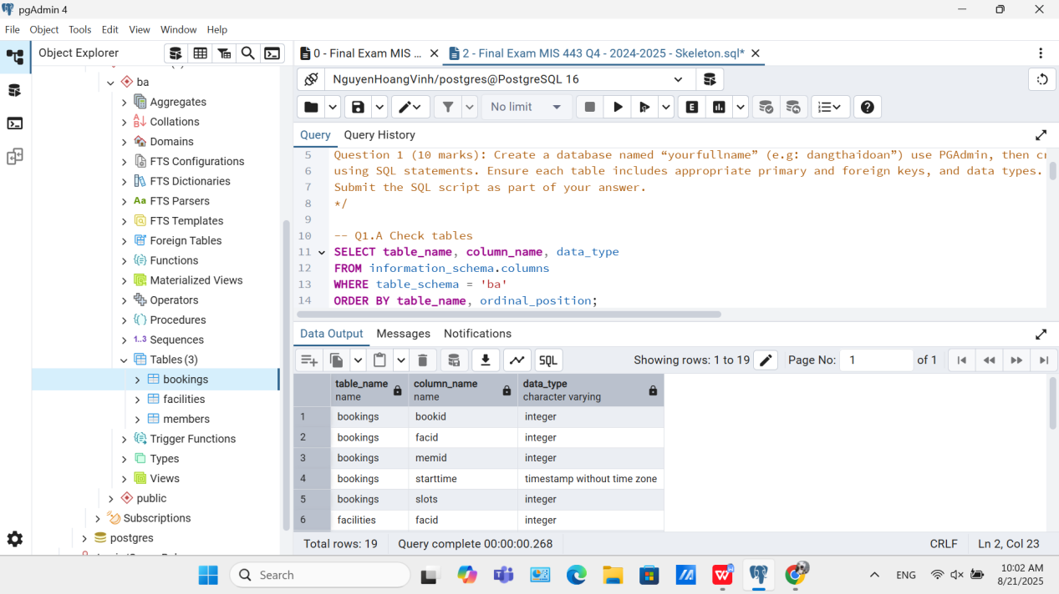

1. **Check table student:**

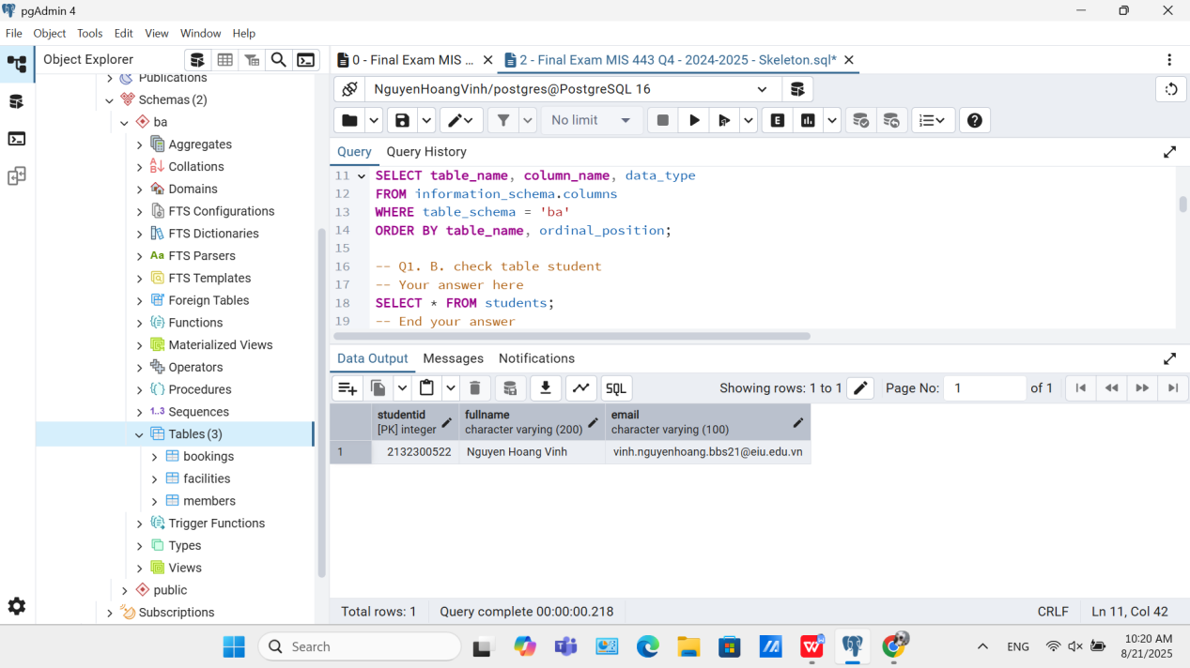

**Question 2: Write an SQL query to find the top 3 facilities that have been booked the most number of total slots (not just number of bookings). Display their facility ID and the total number of slots booked, sorted from highest to lowest.**

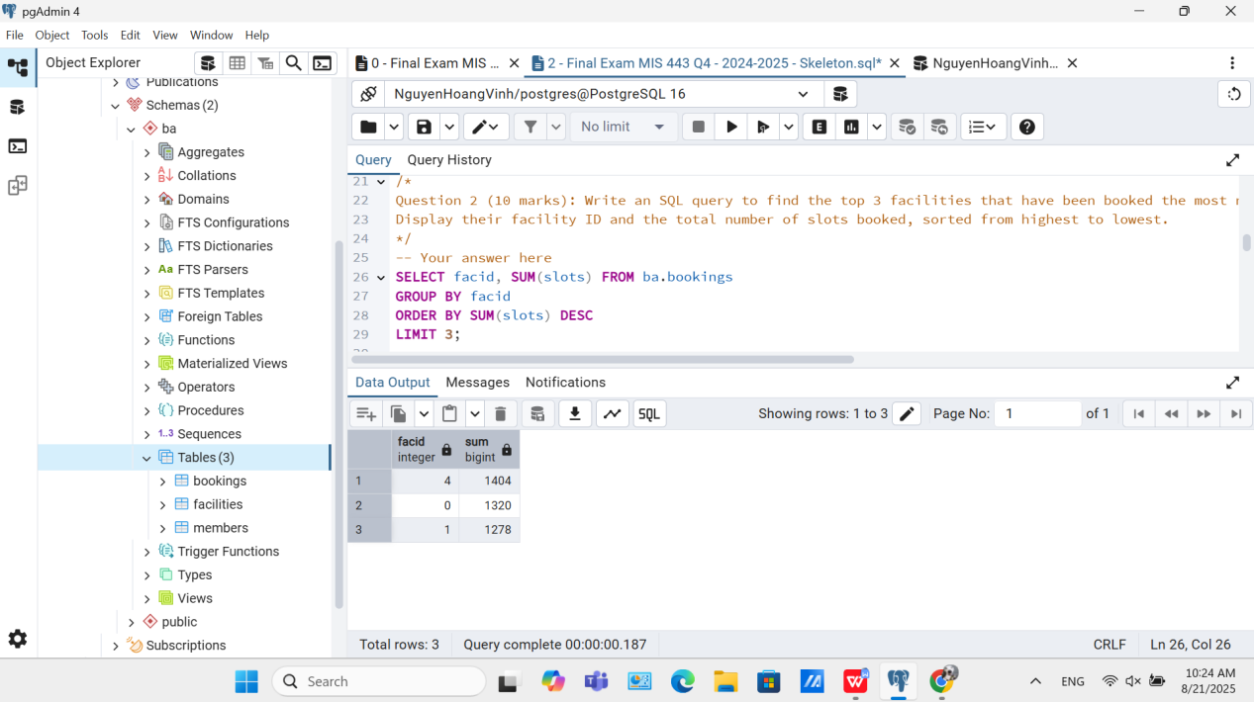

**Question 3: Write an SQL query to display all bookings that lasted more than 2 slots, along with the member ID, facility ID, and facility name, sorted by member ID and then by start time (ascending).**

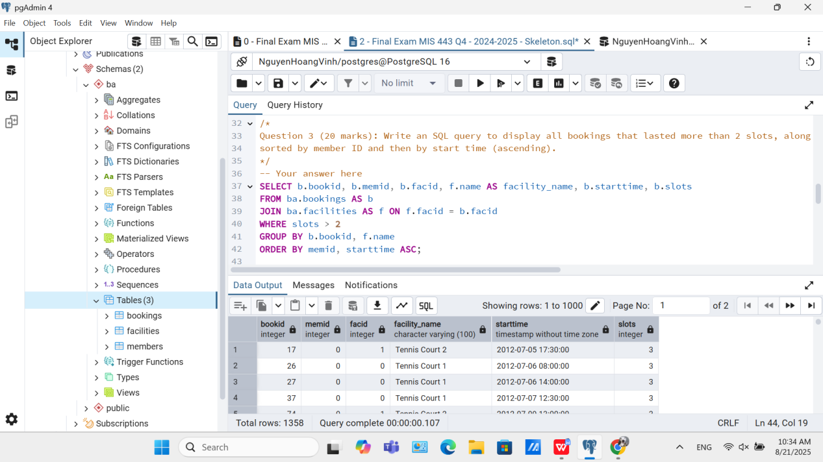

**Question 4: Write an SQL query to display each member and the number of bookings they made for facility ID = 1. Include all members, even those who have never booked that facility.**

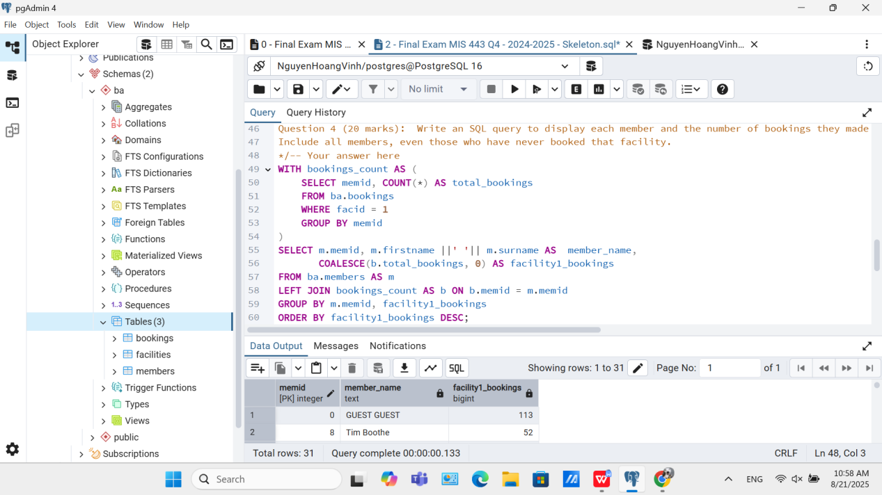

**Question 5: Write an SQL query to show the total number of slots booked by guests (memid = 0) for each facility. Include the facility name and display the result in descending order of total slots used.**

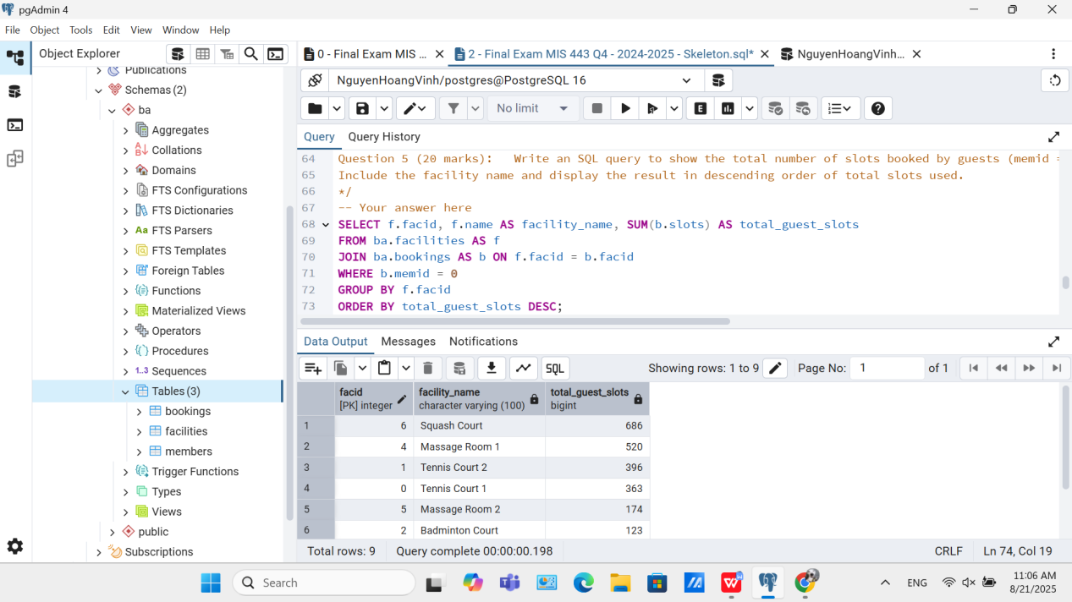

**Question 6: Write an SQL query to rank members based on their total number of bookings. Members with the same number of bookings should have the same rank. Only include members who have made at least one booking**

